Quiz: Illustration & Reproduction Processes
Prof. Moy

Name:

Type your answers below, using as much space as you need,
and save as a PDF when done.
or
Write down your answers on a sheet of paper, numbering each question clearly,
and send me a photo.

Email your photo or file to me or drop it in your Dropbox—whatever makes your life easier.

1. What is the difference between RELIEF printing and INTAGLIO printing? Explain in your own words.

2. What is this (pictured below)? Explain its function and how it exemplifies the themes & discussion points from last week’s class.

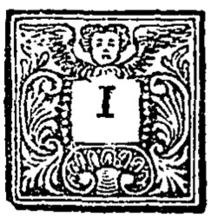

3. Starting what century were woodcuts regularly used as an illustration technique? How about copper engravings? Which method produced higher-quality illustrations?

4. Name 3 styles of engravings. Tell me what you know about each—or what artistic medium they might be compared to.

5. Explain the principle concept behind lithography. How does this mode of reproduction work?

