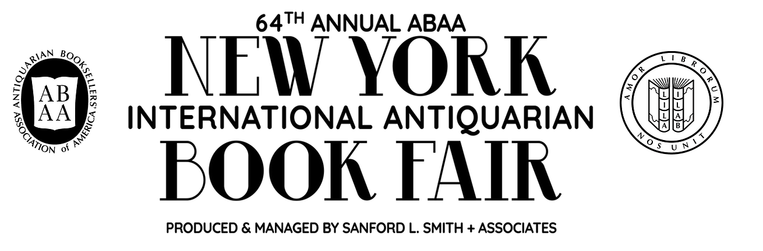
NY International Antiquarian Book Fair – Optional Field Trip
Thursday-Sunday, April 5-7, 2024
(pick any day – opens at noon)
https://www.nyantiquarianbookfair.com/visitor-info

Email Prof. Moy for your free ticket

Your assignment following your visit the Book Fair is to write a polished, exciting 3-4 paragraph account of some aspect of your trip. Like a short newspaper column, your piece should be full of details and description, giving a sense of what you learned to a reader who did not have the opportunity to experience what you did today. It should be accompanied by 2 high-quality photos that exemplify the subject you are writing about.

Submit everything in your Dropbox as a PDF document with the photos embedded right onto the page. Examples can be seen on the “Blog” page of the CUNY Academics Commons page here. Make sure that your report is highly detailed, including any terms of the trade you have learned along the way. Do not write a piece that is general or specific or that could have been written by someone who did not attend today’s events.

The best way to approach this is to choose an artifact (book, letter, manuscript) at the Antiquarian Book Fair and start to ask questions about it. Speak with the booksellers and see if you can glean anything remarkable about it or any stories worth capturing. Don’t be shy to ask them questions! You can introduce yourself as an English literature student to start off the conversation.
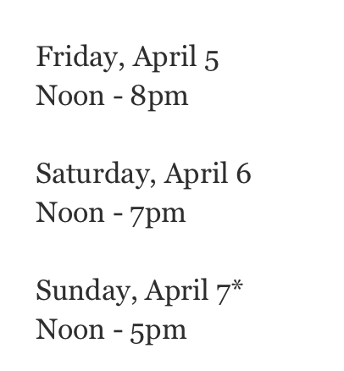
You may also wish to write about the profession of bookselling or bookcollecting. In this case, your object of study would be a person, their career, or personal history. What path did they take to end up where they are now? What kind of training did they receive, where, and for how long? You may choose to present this in a short interview format accompanied by some photos with an introduction and conclusion.

Park Avenue Armory is located at 643 Park Avenue between 66th and 67th Streets. The closest subway station is the 6 train to 68th St. (Hunter College).
​

Bag Check
All backpacks, messenger bags, briefcases, satchels larger than 9" x 4" x 12" (or 21 x 10 x 30 centimeters), and umbrellas and coats must be left at our complimentary Coat Check. Personal handbags (smaller than the above), delivery packages, and purchases are subject to inspection at any time. Items such as maps, manuscripts, artwork, or books are not permitted into the fair, unless accompanied in and out of the fair by a badged exhibitor.

